**IMPLEMENTING CRM FOR RESULT TRACKING OF A CANDIDATE WITH INTERNAL MARKS.**

**INTRODUCTION**

**1.1 Overview**

**Project aim is to provide real-time knowledge for all the students who have basic knowledge of CRM for result tracking of a candidate with internal marks. Candidate scoring, LinkedIn Extension, Drag & Drop Pipeline, Task automation, Collaboration, AI recruitment ATS & CRM for Recruiters. All-in one platform to manage hiring process.**

**1.2 Purpose**

**Administrator should be able to create all base data including semester, candidate , course and lecturer. Lecturer should have the ability to create internal results, dean, who is one of the lecturer, should be the only one with ability to update internal results, re-evaluation can be initialised by candidate for all internal results. Now only dean can update the mark after re-evaluation.**

**PROBLEM DEFINITION & DESIGN THINKING**

**2.1 Empathy Map**

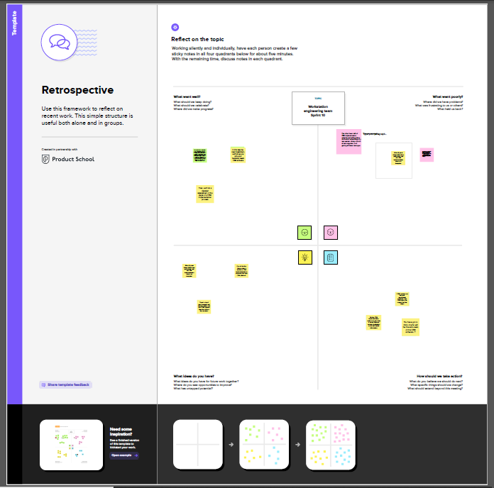

**2.2 IDEATION & BRAINSTORMING MAP**

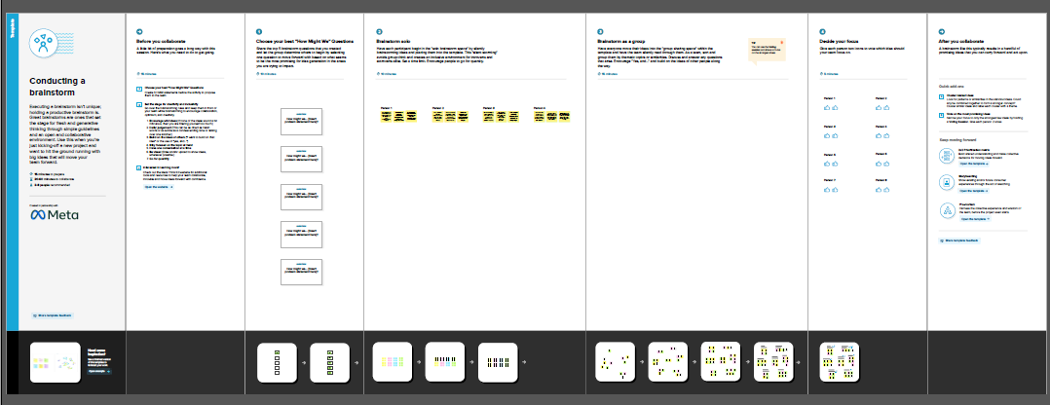

**RESULT**

**3.1 DATA MODEL**

|  |  |
| --- | --- |
| **OBJECT NAME** | **FIELDS THE OBJECT** |
| **Result Tracking** | |  |  | | --- | --- | | **FIELD LABLE** | **DATA TYPE** | | **Semester Name** | **Text** | | **Candidate Name** | **Text** | | **Course Details** | **Text** | | **Lecturer Details** | **Text** | | **Internal Result** | **Text** | |

**3.2 ACTIVITY & SCREENSHOT**

**ACTIVITY: 1**

**Creating Developer Account Creating a developer org in salesforce.**

1. **Go to developer.salesforce.com/**
2. **Click on sign up.**
3. **On the signup form, enter the following details:**
4. **First name & Last name**
5. **Role**
6. **Company: Collage Name**
7. **Country: India**
8. **Postal Code : pin code**
9. **Username: Should be a combination of your name and company This need not be an actual email.id ,you can give anything in the format:** [**username@organizaation.com**](mailto:username@organizaation.com)

**Click on sign up after filling these.**

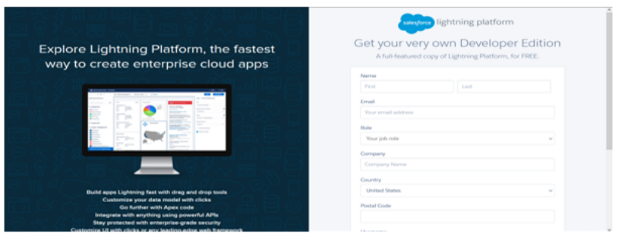

**Account Activation**

**Go to the inbox of the email that you used while signing up. Click on the verify account to activate your account. The email may take 5-10mins, as**

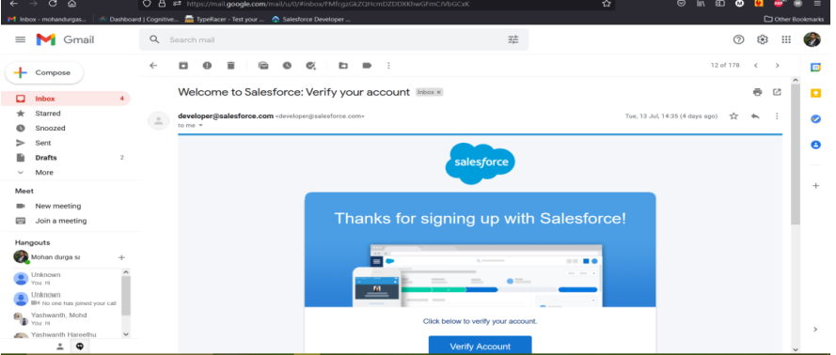

**Login To Your Salesforce Account**

**1.Go to salesforce.com and click on login.**

**2.Enter the username and password that you just created.**

**3.After login this is the home page which you will see.**

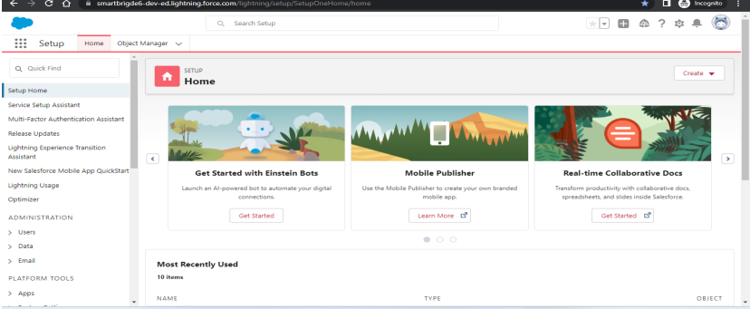

**Salesforce Login htttps://login.salesforce.com**

**CUSTOM OBJECTS:**

**1.Semester**

**2.Candidate**

**3.Course Details**

**4.Lecturer Details**

**5.Internal results**

**ACTIVITY:2**

**To Create an object:**

**Creation of Objects for Candidate Internal Result Card, For this Candidate Internal Result Card we need to create 5 objects i.e Semester, Candidate, Course Details, Lecturer Details, Internal Results.**

**The below steps will assist you in creating those objects.**

**● Click on the gear icon and then select Setup.**

**● Click on the object manager tab just beside the home tab.**

**● After the above steps, have a look on the extreme right you will find a Create Dropdown click on that and select Custom Object. On the Custom Object Definition page, create the object as follows:**

**● Label: Semester**

**● Plural Label: Semesters**

**● Record Name: Semester Name**

**● Check the Allow Reports checkbox**

**● Check the Allow Search checkbox**

**● Click Save.**

**● Now create a custom tab. Click the Home tab, enter Tabs in Quick Find and select Tabs.**

**● Under Custom Object Tabs, click New.**

**● For Object, select Semester.**

**● For Tab Style, select any icon.**

**● Leave all defaults as is. Click Next, Next, and Save.**

**To Navigate to Setup page: Click on gear icon → click setup.**

**From the setup page → Click on Object Manager → Click on Create → Click on Custom Object**

**Enter the label name, plural label name, click on Allow reports, Allow search → Save.**

**FIELDS AND RELATIONSHIP**

**ACTIVITY:3**

**Creation of fields:**

**● Click the gear icon and select Setup. This launches Setup in a new tab.**

**● Click the Object Manager tab next to Home.**

**● Select Semester.**

**● Select Fields & Relationships from the left navigation, and click New Now ready to make a custom field. Let's do this!**

**● Select the Text as the Data Type, then click Next.**

**● For Field Label, Enter Semester Name.**

**● Click Next, Next, then Save**

**Go to setup → click on Object Manager → type object name in search bar → click on the object.**

**Now click on “Fields & Relationships” → New**

|  |  |  |  |  |
| --- | --- | --- | --- | --- |
| **SEMESTER** | **CANDIDATE** | **COURSE DETAILS** | **LECTURER DETAILS** | **INTERNAL RESULS** |
| **Semester Name** | **Candidate Name** | **Course Name** | **Lecturer Role** | **Candidate ID** |
| **Course(lookup)** | **Candidate Id** | **Course ID** | **Lecturer Name** | **Course ID** |
|  | **Semester Name** |  | **Course ID** | **Marks** |
|  | **Internal results(lookup)** |  | **Course(lookup)** |  |

**LIGHTING APP**

**ACTIVITY:4**

**Create the Candidate Internal Result Card app:**

**● From Setup, enter App Manager in the Quick Find and select App Manager. ● Click New Lightning App. Enter Candidate Internal Result Card as the App Name, then click Next**

**● Under App Options, leave the default selections and click Next.**

**● Under Utility Items, leave as is and click Next.**

**● From Available Items, select Semester, Candidate, Course Details, Lecturer Detail, Internal Results and move them to Selected Items. Click Next.**

**● From Available Profiles, select System Administrator and move it to Selected Profiles. Click Save & Finish.**

**● To verify your changes, click the App Launcher, type Candidate Internal Result Card and select the Candidate Internal Result Card app.**

**Go to setup page → search “app manager” in quick find → select “app manager” → click on New lightning App**

**Fill the app name in app details and branding →Next → (App option page) keep it as default → Next → (Utility Items) keep it as default → Next → (Add Navigation Items) → Next → (Add User Profile) Add System Administrator → Next**

**Select the items from the search bar and move it using the arrow button → Next.**

**Search profiles in search bar → click on the arrow button → save & finish**

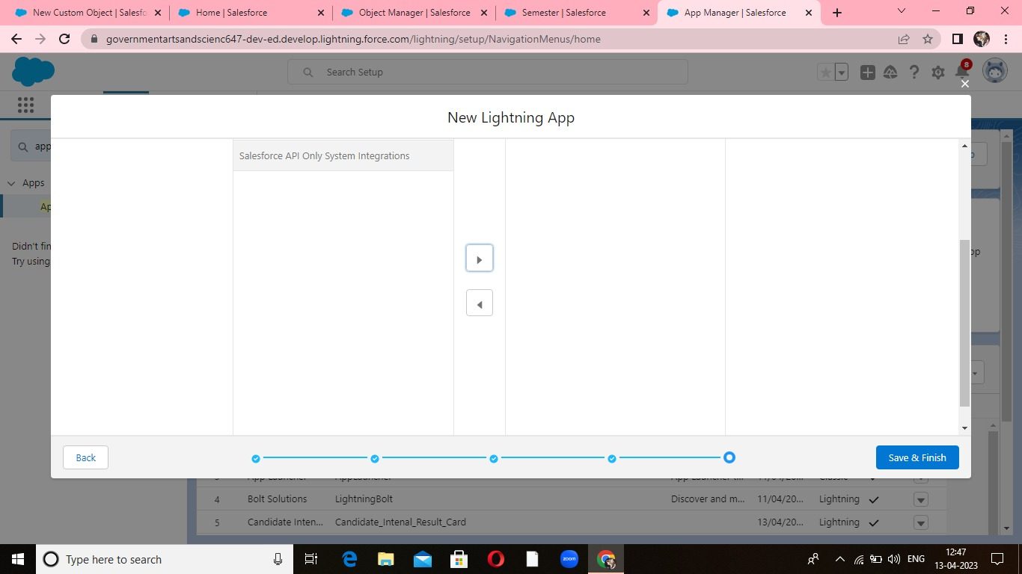

**USER**

**ACTIVITY:5**

**Creating a Users:**

**1. From Setup, in the Quick Find box, enter Users, and then select Users.**

**2. Click New User.**

**3. Enter the user’s name John Martin and (Your) email address and a unique username in the form of an email address. By default, the username is the same as the email address.**

**4. Select a Role(none)**

**5. Select a User Licence As salesforce.**

**6. Select a profile as Salesforce User.**

**7. Check Generate new password and notify the user immediately to have the user’s login name and a temporary password emailed to your email.**

**REPORTS**

**ACTIVITY:6**

**Reports and dashboards:**

**1. From the Reports tab, click New Report.**

**2. Select the report type as Candidate with candidate Marks for the report, and click Create.**

**3. Customise your report, then save or run it.**

**Go to the app → click on the reports tab**

**Select report type from category or from report type panel or from search panel → click on start report.**

**Customize your report, then save or run it.**

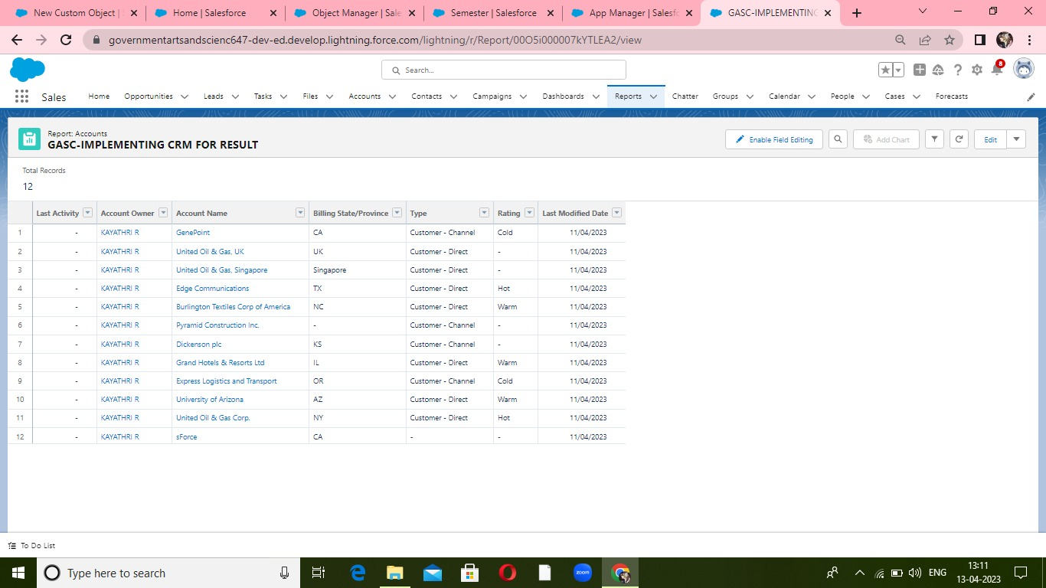

**DASHBOARDS**

**ACTIVITY:7**

**Create a Dashboard:**

**1. Click the Dashboards tab.**

**2. Click New Dashboard.**

**3. Name your dashboard Candidate Board. Leave all other fields as is and click Create.**

**4. Click + Component.**

**5. For Report, select Candidate Marks by Stage. Click Select. ...**

**6. For Display As, select Vertical Bar Chart and click Add.**

**7. Click Save.**

**8. Click Done**

**TRAILHEAD PROFILE PUBLIC URL**

**Team Lead – http://trailblazer.me/id/mareesrm28**

**Team Member 1 – http://trailblazer.me/id/kayu3**

**Team Member 2 – http://trailblazer.me.id/malav89**

**Team Member 3 – http://trailblazer.me.id/mahan78**

**APPLICANT**

**# Interactive recruitment pipeline**

**# Flexible and powerful search functionalities**

**# Search multiple criteria at once**

**# Automated resume reformatting**

**#Sync your mailbox and calendar**

**# Notify all your candidates and clients in batch**

**CONCULSION**

**It facilitates things by giving you and the customer, ease of communication, organized data, and improved customer service. All of this will streamline the process of making sure needs are met and actions get resolved in a timely manner.**